Lab 6 **Confusion Matrix and Cross validation**

**1.** **Perform the confusion matrix and k fold cross validation on the IRIS dataset, simultaneously plot the confusion matrix figure for normalized and non-normalized data.**

//**plot the confusion matrix figure**

def plot_confusion_matrix(predicted_labels_list, y_test_list):

cnf_matrix = confusion_matrix(y_test_list, predicted_labels_list)

np.set_printoptions(precision=2)

# Plot non-normalized confusion matrix

plt.figure()

generate_confusion_matrix(cnf_matrix, classes=class_names, title='Confusion matrix, without normalization')

plt.show()

# Plot normalized confusion matrix

plt.figure()

generate_confusion_matrix(cnf_matrix, classes=class_names, normalize=True, title='Normalized confusion matrix')

plt.show()

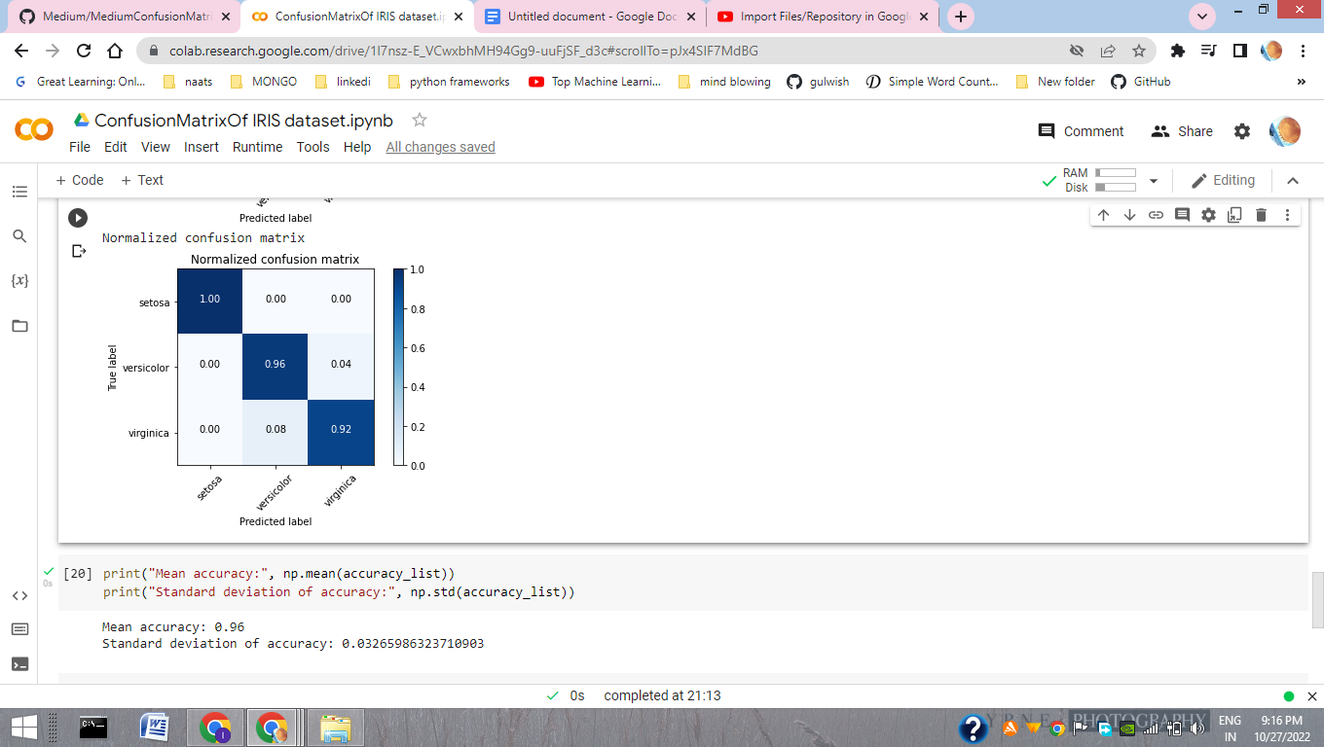

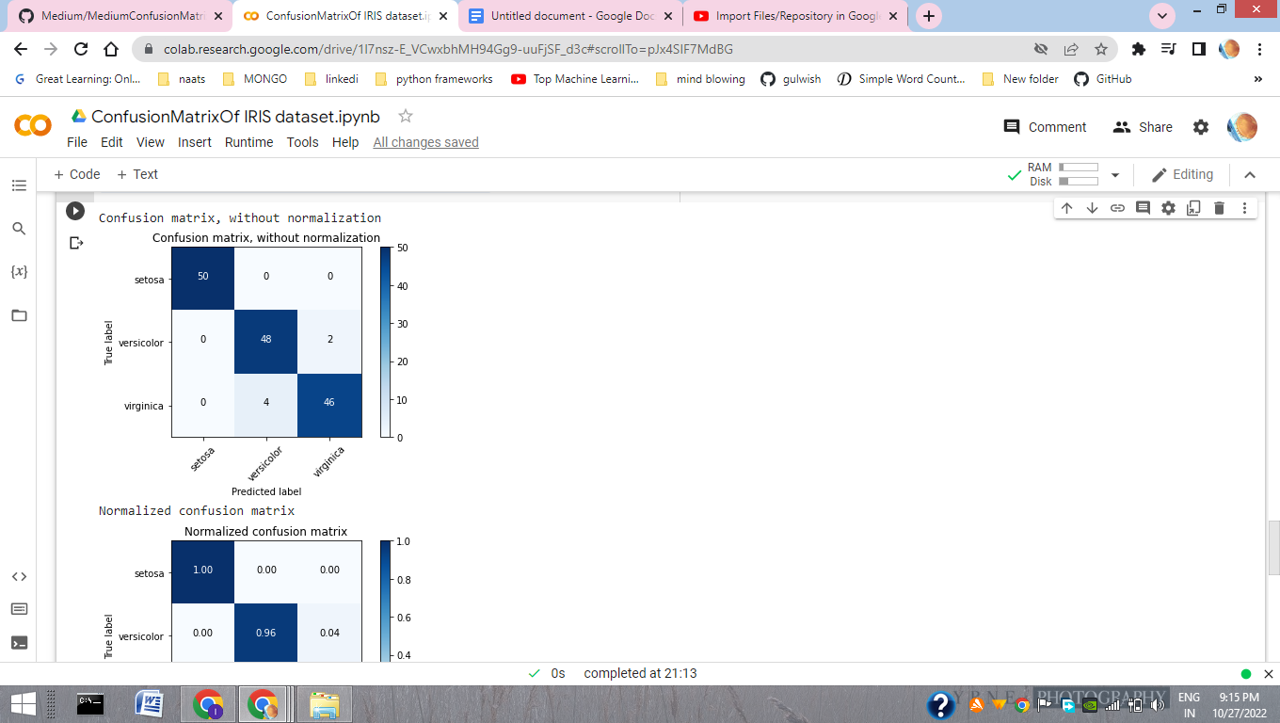

**//Perform the confusion matrix and k fold cross validation on the IRIS dataset, using** evaluate_model defined

#perform

predicted_target, actual_target, accuracy_list = evaluate_model(data, target)

#plot

plot_confusion_matrix(predicted_target, actual_target)

